**ACT Practice Set 2** Name_________________________

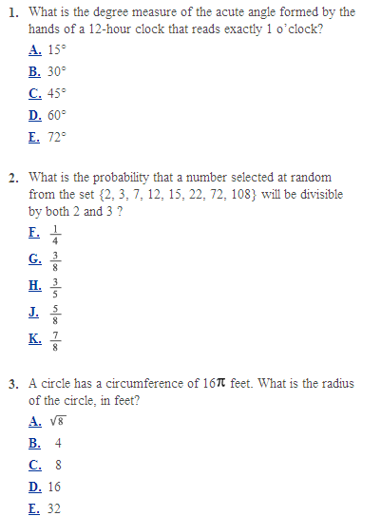Please show all work in the space provided. The actual math portion consists of 60 questions in 60 mins.

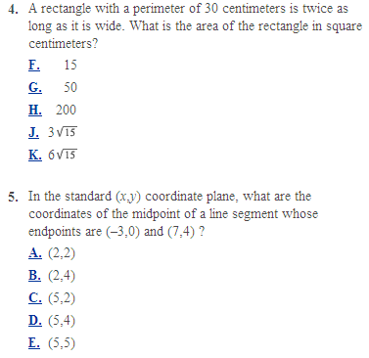

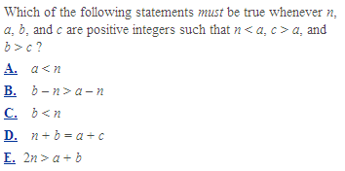6.

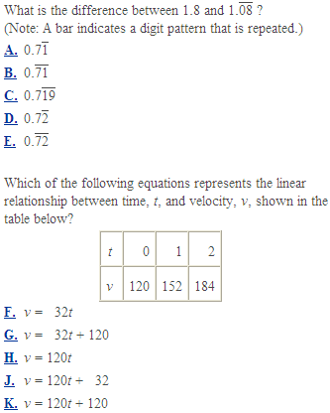

7.

8.

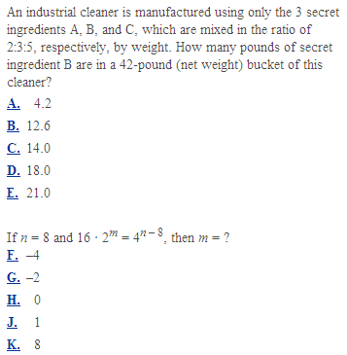

9.

10.